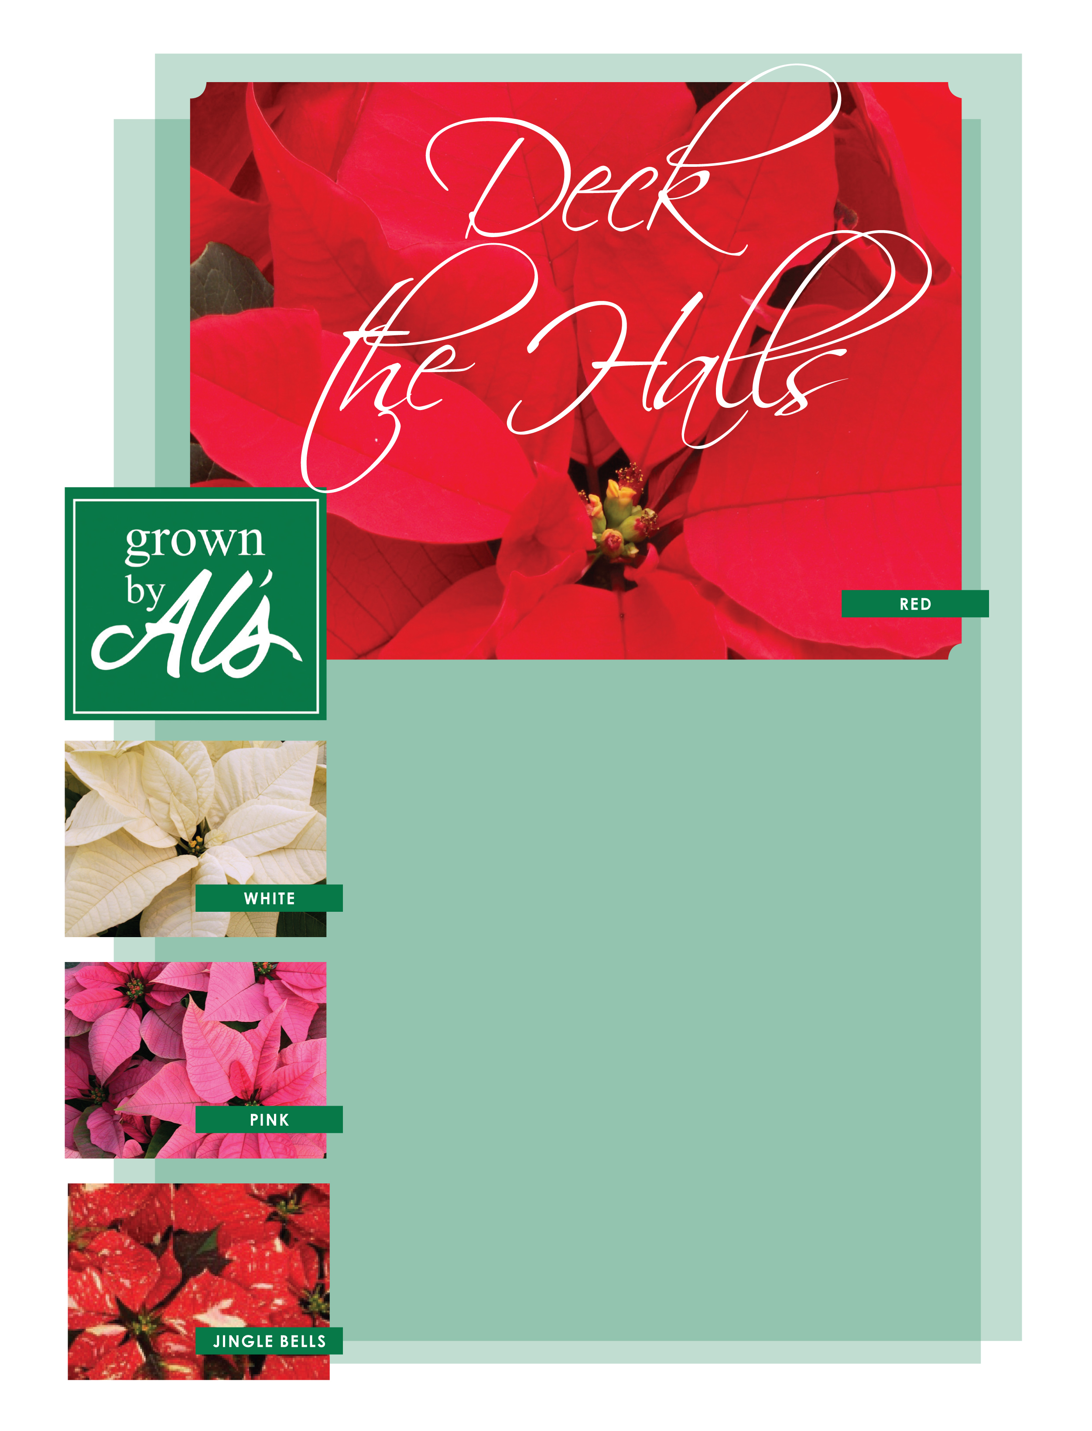

**Support Wilsonville High School Grad Night**

**by Purchasing Poinsettias for the Holidays!**

* Mail in your order and payment to WHS PO Box 14, Wilsonville, Oregon 97070, or turn into WHS Grad Night Box (in Main Office).
* **Orders due by November 10th.  Checks made out to WHS Grad Night**.
* You will receive a certificate to redeem at Al’s Garden Center in Wilsonville. **Certificates are redeemable from November 16th through December 5th.**
* If you have any questions, please email us at whsgradnight2019@gmail.com.

**About the Poinsettias:**

* Grown locally by Al’s Garden Center, the poinsettias are beautiful and will last through the holidays and beyond.
* You will have a choice between 6.5” or 8.5” poinsettias, which are between 15”-20” in height with six or more blooms. The cost is $15 and $30 each, respectively.
* You will be able to choose from 45 different varieties of poinsettias (Examples are shown on the left).

**Quantity**

6.5 Inch _____ x $15.00 = ________

8.5 Inch _____ x $30.00 = ________

**TOTAL.** $________

Name: ___________________________________________________

Email: _________________________ Phone: ____________________

***Thank you for your support towards the 2019 graduating class!***